**CSE 512: Phase 2 Report**

By,

Group 24

(Stephanie Lang, 1202845808, smlang1@asu.edu)

(Sandeep Nimmagadda)

(Saranya Reddy Vajrala)

(Rajesh Vakkalagadda)

(Jayanth Reddy Bogasamudram)

Table of Contents

Phase 1 Execution Time Comparisons 2

Phase 1, Task 2 Differences between A & B 2

Phase 1, Task 3 Differences between A & B 2

Phase 1, Task 4 Differences between A & B 2

Phase 1, Task 4 Differences between A & C 2

Phase 1 & Phase 2 Comparisons 2

Phase 1 Task A 2

Phase 1 Task B 2

Phase 1 Task C 2

Phase 2 Task A 2

Comparisons from Phase 1 & Phase 2 2

Conclusion 2

# Phase 1 Execution Time Comparisons

## Phase 1, Task 2 Differences between A & B

**Task 2 A (18:41 – 18:46)**

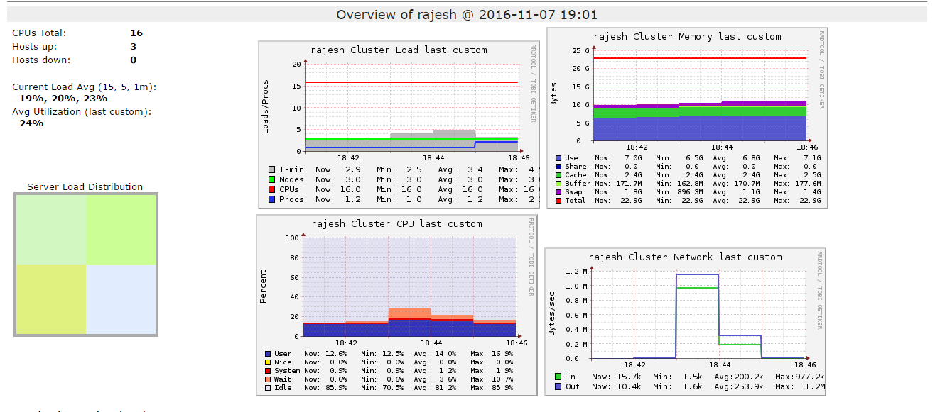

**Task 2 B (18:47 – 18:53)**

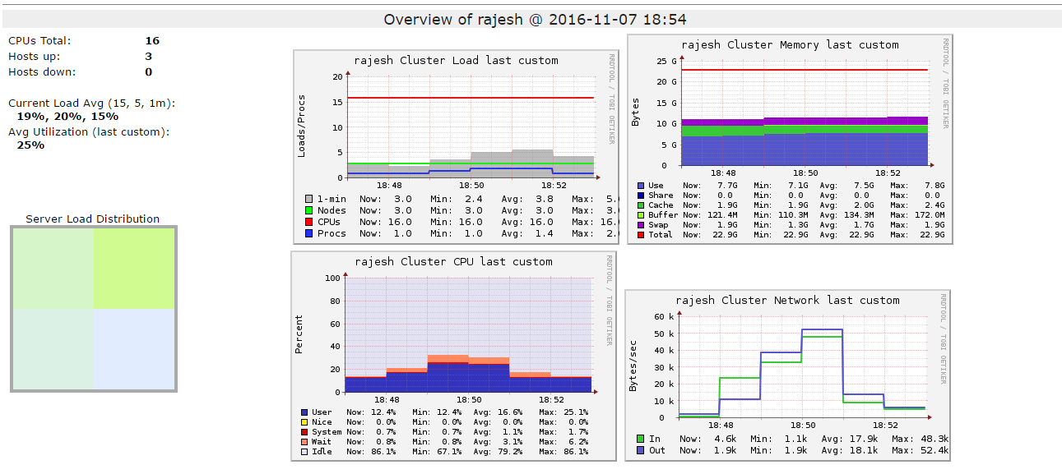

## Phase 1, Task 3 Differences between A & B

**Task 3 A (18:58 – 19:02)**

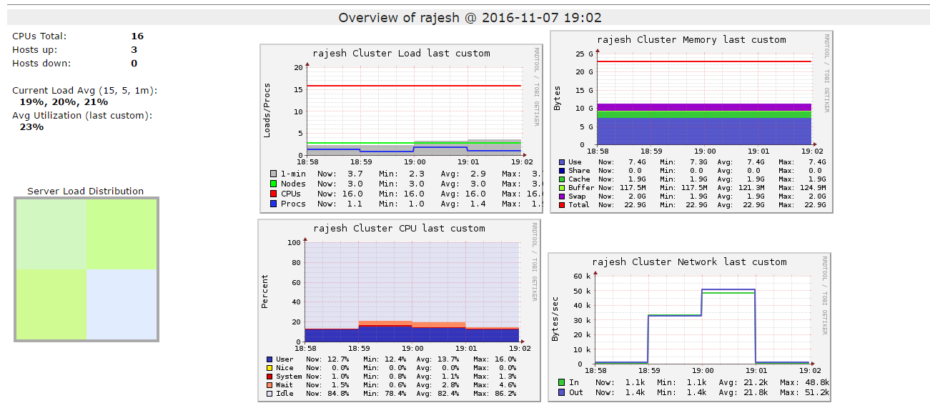

**Task 3 B (19:03 – 19:07)**

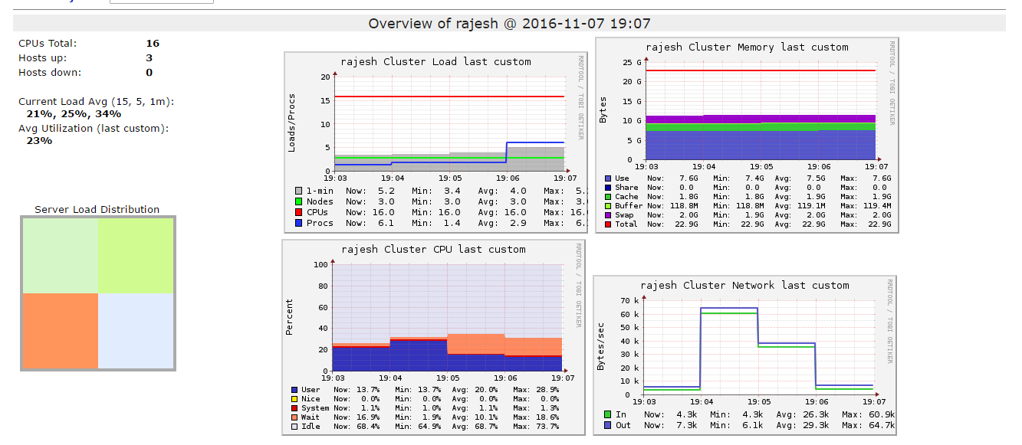

## Phase 1, Task 4 Differences between A & B

**Task 4 A (19:?? – 19:??)**

**Task 4 B (18:?? – 18:??)**

## Phase 1, Task 4 Differences between A & C

**Task 4 A (18:?? – 18:??)**

**Task 4 C (18:?? – 18:??)**

# Phase 1 & Phase 2 Comparisons

## Phase 1 Task 4 A

## Phase 1 Task 4 B

## Phase 1 Task 4 C

## Phase 2 Task A

## Comparisons from Phase 1 & Phase 2

# Conclusion